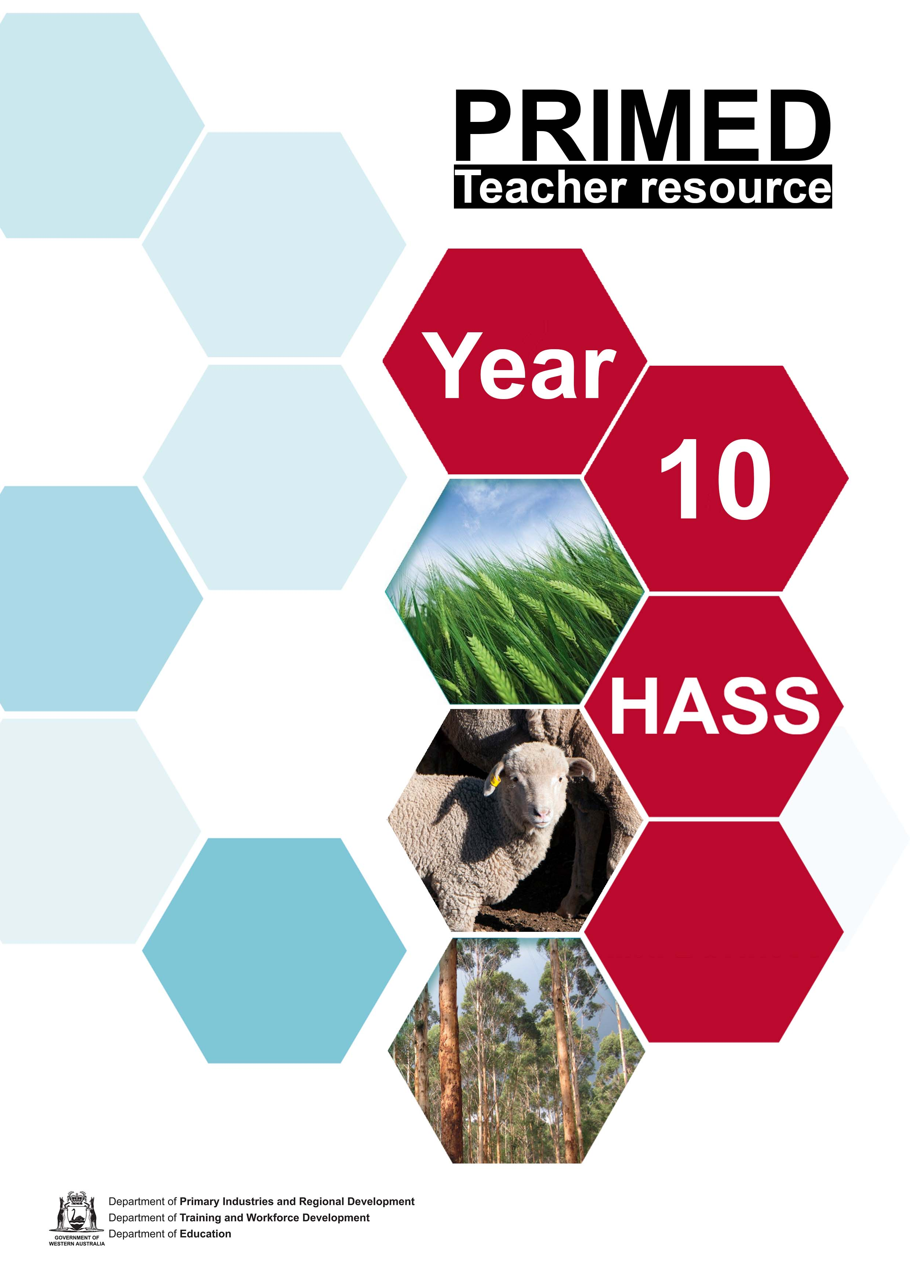

Teaching guide: The Business of Food Production

Resources overview

PRIMED mission
To increase student understanding of agriculture, fisheries, fibre, forestry and food (primary industries) careers to enable Year 7–12 students to make informed career-pathway choices.

About the resource set
These resources provide rich tasks focused on the Western Australian Curriculum within a primary industries context.
This series of activities challenges students to explore primary industries and the production of food and fibre commodities in Western Australia (WA).

Curriculum links
This resource is designed to be a learning pathway for Year 10 Humanities and Social Science (HASS) students to develop their understanding of the Western Australian Curriculum HASS content descriptions:
HASS Knowledge and understandings:
- The ways that governments manage the economy to improve economic performance and living standards, and to minimise the effects of externalities (ACHEK052).
- The ways businesses organise themselves to improve productivity (ACHEK054).
- Ways that businesses respond to improved economic conditions (ACHEK054).

HASS skills
Questioning and researching
- Identify current personal knowledge, gaps, misconceptions, currency of information, personal perspective and possible perspectives of others (WAHASS79)
- Use a range of methods to collect, select, record and organise relevant and reliable information and/or data from multiple sources that reflects the type of analysis of information that is needed (eg questionnaires, surveys, emails, discussion lists, tables, field sketches, annotated diagrams), with and without the use of digital and spatial technologies (WAHASS82)
Analysing
- Analyse information and/or data in different formats (eg to explain cause and effect relationships, comparisons, categories and subcategories, change over time) (WAHASS86)
- Account for different interpretations and points of view/perspectives in information and/or data (eg from tables, statistics, graphs, models, cartoons, maps, timelines, newspapers) (WAHASS87)
- Analyse the 'big picture' (e.g. put information and/or data into different contexts, reconstruct information by identifying new relationships, identify missing viewpoints or gaps in knowledge) (WAHASS88)
- Apply subject-specific skills and concepts in familiar, new and hypothetical situations (WAHASS89)
Evaluating
- Critically evaluate information and/or data and ideas from a range of sources to make generalisations and inferences; propose explanations for patterns, trends, relationships and anomalies; predict outcomes (WAHASS91)
Communicating and reflecting
- Select a range of appropriate formats based on their effectiveness to suit audience and purpose, using relevant digital technologies as appropriate (WAHASS92)
- Deconstruct and reconstruct the collected information and/or data into a form that identifies the relationship between the information and the hypothesis, using subject-specific conventions, terminology and concepts (WAHASS94)

Resource set structure
The resource set is structured around constructivist learning principles using a 5E model: engage, explore, explain, elaborate and evaluate. It is designed to be flexible so that teachers can use all or parts of the resource that they consider appropriate for their students.
With this combined approach:
- Students’ interest and minds are engaged by exploring the world of business associated with food production.
- Students explore the variety of careers and businesses involved in food and fibre production.
- Students explain how the Western Australian Government supports businesses associated with primary industry.
- Students elaborate by investigating a variety of business case studies.
- Students evaluate their learning by responding to an open-ended question.

Educational process | Teaching and learning focus | Resources
Engage  Engage students and elicit prior knowledge. | Module 1:  Students are introduced to the topic and presented with the following open-ended question  ‘How can governments, businesses and consumers interact to ensure a sustainable, efficient and cost-effective food production system?’  As they progress through the modules, students gather ideas and present their thoughts at the completion of all modules. | Teacher resources:  - Hexagonal thinking  - A user's guide to hexagonal thinking  Video resources:  - Feeding a Hungry Planet  - The Future of Agriculture  Student worksheets:  - Student worksheet 1.1 Vocabulary  - Student worksheet 1.2 Hexagonal thinking  - Student worksheet 1.3 Frayer Model
Explore  Find out more about the topic, concept or idea. | Module 2:  Students investigate careers and businesses involved with primary industry along the supply chain. | Teacher resources:  A selection of websites that provide some examples of careers and businesses  - Primary industry careers  - Jobs by Industry  - Buy West Eat Best  - Agritourism Western Australia  - Video: The Business of Food Production  Student worksheets:  - Student worksheet 2.1 Businesses associated with the supply chain  - Student worksheet 2.1a Using the inquiry approach for research
Explain  Use a variety of methods to collect relevant information and/or data from a range of appropriate sources, such as print, digital, audio, visual and fieldwork. | Module 3:  Students will discuss the role of governments in primary industry. | Teacher resources (background information):  - PPT – Target Market Opportunities  - PPT – Pathways to Competitiveness  - PPT – Premium Agri-food Market Opportunities  - PPT - Research Highlights 2021 Summary  - PPT – The Primary Industries Plan  Student worksheets:  - Information sheets Primary Industry Plan strategic themes 1 – 5  - Student worksheet 3.1 Strategic initiatives

Elaborate  Extend understanding to a new context or make connections to additional concepts through a student-planned investigation. | Module 4:  Students investigate companies demonstrating improved productivity. | Student resource  - Case Study - Eden Towers  - Case Study – Geraldton Fisherman’s Co-operative  - Case Study - Handasydes Strawberries  - Student worksheet 4.1 Business case study  - Student worksheet 4.2 Extent barometer
Evaluate  Students re-represent their understanding and reflect on their learning journey, and teachers collect evidence about the achievement of outcomes. | Module 5:  Students investigate the WA Food Innovation Precinct.  Students present their responses to the open-ended statement. | Teacher resource  - Peel Business Park  Other resources  - Student worksheet 5.1 Mind map

Learning resources and sequence

Module 1: (2 - 3 lessons)
ENGAGE
EXPLORE
EXPLAIN
ELABORATE
EVALUATE

Learning intentions
Students will be able to:
- Define key terms associated with business, agricultural and agribusiness systems.

Background information
Students are presented with an open-ended question and asked to respond at the end of the five modules. Each module is designed to provide information that will assist students in generating a response. There is scope for additional and/or different lines of inquiry including incorporating the United Nations Sustainable Development Goals (UN SDGs).
Research indicates that there will be a need for economies around the world to increase production of food and fibre to cater for rising world population while at the same time address global issues such as climate change. Governments provide data, research and grants that allow businesses to adapt. Businesses need to consider how they will minimise the environmental, economic and social impacts while increasing productivity and responding to economic conditions. Consumers are influential in how and why agricultural systems are used and therefore need to develop an understanding of these systems and develop relationships with businesses along the supply chain.

Resources and equipment
Teacher resources:
- Hexagonal thinking
- A user's guide to hexagonal thinking
Video resource:
- Feeding a Hungry Planet
- The Future of Agriculture
Student worksheets:
- Student worksheet 1.1 Vocabulary
- Student worksheet 1.2 Hexagonal thinking
- Student worksheet 1.3 Frayer Model

Instructions for suggested activities
- Present the following question to students:
‘How can governments, businesses and consumers interact to ensure a sustainable, efficient and cost-effective food production system?’
Students will be required to respond to the question at the end of the learning sequence.
- View ‘Feeding a Hungry Planet’ or ‘The Future of Agriculture’
- Class to brainstorm a list of words associated with agriculture, business and agribusiness systems.
- Distribute Student worksheet 1.1 Vocabulary.
- Compare brainstorm results with vocabulary list and add extra words as required.
- Students to define the terms listed.
Alternative activity:
Distribute Student worksheet 1.3 Frayer Model. Each student to explain one term from the list. Students share explanations of the term to the class. Display the worksheets.
- Using the same terms, students complete Student worksheet 1.2 Hexagonal thinking.
- Students share their ideas in groups of four. Select one idea to share with the class.

Module 2: (1 – 4 lessons)
ENGAGE
EXPLORE
EXPLAIN
ELABORATE
EVALUATE

Learning intentions
Students will:
- Investigate the types of businesses and careers associated with each element of the supply chain.

Background information
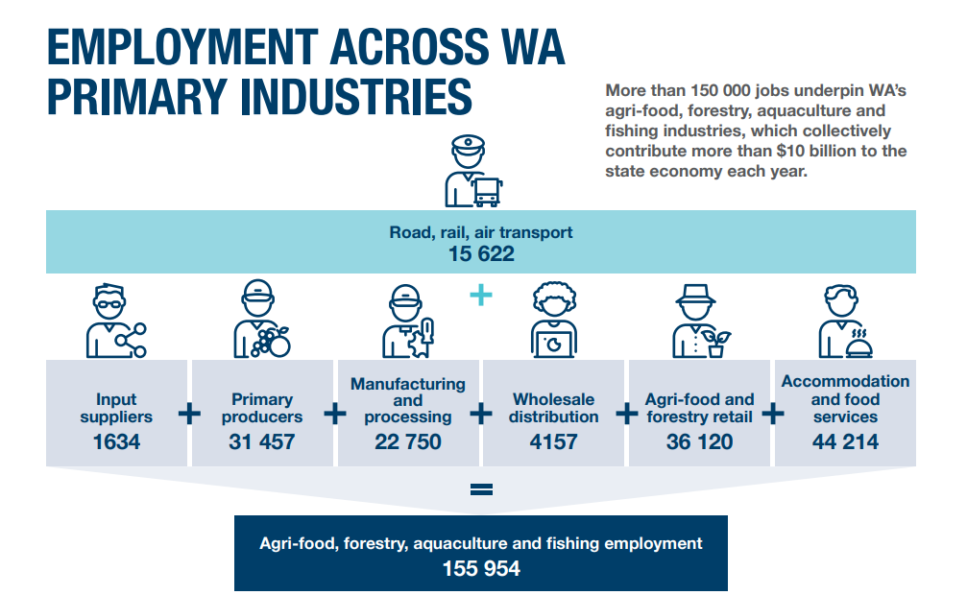
Image 1.1.1
Primary Industries Development Research Highlights 2021
The image above can be found on page 16 of the Research Highlights 2021 Report. Highlight the number of people employed in each sector and the value of primary industry to the state economy.
This activity is designed to encourage students to investigate the businesses and careers related to primary industries along the supply chain from production to consumption. This activity can be adapted to be completed in one lesson or extended to allow for detailed research and presentations to the class.
Some businesses and careers represent one aspect of the supply chain while others may extend along the whole chain. The purpose is to encourage students to think about the diverse range of options within primary industry.
Schools located in agricultural areas can focus on local businesses. Change the examples to suit your context.

Resources and equipment
Teacher resources:
A selection of websites that provide some examples of careers and businesses
- Primary industry careers
- Jobs by Industry
- Buy West Eat Best
- Agritourism Western Australia
- Video: The Business of Food Production
Student worksheets:
- Student worksheet 2.1 Businesses associated with the supply chain
- Student worksheet 2.1a Using the inquiry approach for research

Instructions for suggested activities
- As a class, brainstorm businesses and careers associated with primary industry.
- View the video ‘The Business of Food Production’.
- Distribute Student worksheet 2.1, students to classify the examples from the brainstorm under the appropriate supply chain element.
- Students to complete the task on Student worksheet 2.1. Distribute worksheet 2.1a. If necessary, adapt to suit your cohort.

Module 3: (1 – 2 lessons)
ENGAGE
EXPLORE
EXPLAIN
ELABORATE
EVALUATE

Learning intentions
Students will be able to:
- Explain the importance of the primary industry (not including the resource sector) to the Western Australian economy.
- Examine the contribution/influence of the State Government on primary industry.

Background information
All industries, and the businesses that contribute to them, are influenced by a multitude of factors, including federal and state government laws and policy.
The background information demonstrates how State Government policy provides opportunities for businesses in primary industry – from raw materials to processed food and beverage products.
Since 2016, The Western Australian Government, through the Department of Primary Industries and Regional Development (DPIRD), has been focusing some of their resources on supporting the growth of premium and value-add food and beverage businesses through the Food Industry Innovation program.
The program aims to develop the full potential of WA food and beverage businesses that are:
- producing premium products
- adding value to raw produce
- staging their product for domestic and international markets
- creating jobs
- boosting the state's economy.

DPIRD, in conjunction with Coriolis (a consulting company), developed several reports identifying market opportunities for WA businesses. These include:
- Target Market Opportunities Report (March 2016)
- Pathway to Competitiveness WA Agriculture (July 2016)
- Premium Agri-food Market Opportunity (December 2016) (Food Industry Innovation)
Target Market Opportunities Report
This research represented the first step in the Department of Primary Industries and Regional Development's Asian Market Success project, a three-year, $6 million project funded by the State Government's Royalties for Regions program.
An extension until 30 June 2019, announced as part of the State Government’s 2018-19 budget, enabled the project to continue to provide WA agribusiness with additional research for expansion into premium Asian markets, capacity building and the delivery of an export-oriented grants program.
Global trade flows of over 679 food and beverage products from every country to 24 high potential Asian and Middle Eastern target markets were analysed and fed through a multi-stage screening process. At each stage, the results have been combined with interviews with many of Western Australia’s agri-food businesses.
The Target Market Opportunities report identified 20 high growth, high value premium opportunities at the intersection between what Asian consumers want and what WA can produce. These opportunities range from existing products targeted at new and emerging markets, to all new products. All identified opportunities share a common thread; they all have large and growing demand from emerging consumers across Asia and/or the Middle East. In addition to the top 20, a great set of “just missed the cut” products also present great opportunities. According to the research, these opportunities had the potential to deliver an estimated $1.3 billion per year in incremental, new export revenue to WA over five to seven years.
The PowerPoint ‘Target Market Opportunities’ included in the teacher resources summarises the main points from the document.
Further information: Target Market Opportunities: detailed reports
Pathway to Competitiveness WA Agriculture
The Department of Agriculture and Food, WA (DAFWA) commissioned global consultancy Coriolis to produce an independent, data-driven report called the Pathways to Competitiveness report. The report identifies opportunities, constraints and drivers for growth and investment of Western Australian agri-food businesses.
Pathways to Competitiveness looks at key drivers, practices and mechanisms which characterise international competitiveness, and draws lessons from peer regions that have transformed relevant industry sectors over a relatively short time period. For example, dairy activity in New Mexico, pork industry growth in Chile, and agri-food growth in Peru, all highlight what is possible.
What questions does it answer?
- What is required to become globally competitive?
- How did peer countries or industries transform their industries?
- What is the Pathway to Competitiveness?
- What is required for WA to expand beyond a handful of key sectors?
The PowerPoint ‘Pathways to competitiveness’ included in the teacher resources summarises the main points from the document.
For further information: Pathway to Competitiveness Report
Premium Agri-food Market Opportunity
The Premium Agri-food Market Opportunity report was commissioned by the Food Industry Innovation program and completed by Coriolis Research in 2016. The report identifies a shortlist of 20 key food and beverage product opportunities targeting high-value, high-growth markets for WA's premium food industry - narrowed down from more than 500.
It highlights export market value of up to $4 billion across the 20 priority opportunities and analyses the capacity for WA businesses to capture this potential value. The report uses market trend research with a focus on domestic and Asian export markets to identify new and emerging premium food and beverage products that add value to WA's abundant raw materials.
The PowerPoint ‘Premium Agri-food Market Opportunities’ included in the teacher resources summarises the main points from the document.
For further information: Food Industry Innovation
Research Highlights 2021
In the Research Highlights 2021 document, DPIRD states that the State Government is committed to reinvigorating research and development in WA’s primary industries and improving commercial outcomes, industry performance, economic growth and employment.
To achieve this, they are investing in research and digital infrastructure across the regions and building capacity while safeguarding the soil, water and land resources. The ‘Research Highlights 2021’ report summarises the work of 60 (out of 140) current and recently completed projects undertaken by DPIRD.
The PowerPoint ‘Research Highlights 2021 Summary’ included in the teacher resources summarises the main points from the document.
For further information: Primed Industries Development Research Highlights 2021
The background information and PowerPoint summaries are provided for the teacher. However, they can be adapted for use in the classroom using content relevant to your cohort.
Western Australian Agri-food Export eNews
The following link provides a weekly update and interesting/useful articles related to Agri-food business.
Western Australian Agrifood Export eNews
The following links Support for businesses in Australia, Agriculture industry and Fisheries industry provide information about Federal government services and requirements for businesses in primary industries.
Other resources:
- Need for Government Intervention
- Primary Industries Plan 2020-2024

Resources and equipment
Teacher resources (background information):
- PPT – Target Market Opportunities
- PPT – Pathways to Competitiveness
- PPT – Premium Agri-food Market Opportunities
- PPT – The Primary Industry Plan
Student worksheets:
- Information sheets Primary Industry Plan strategic themes 1 – 5
Student Worksheet 3.1 Strategic initiatives

Instructions for suggested activities
Explain the importance of the primary industry (not including the resource sector) to the Western Australian economy.
- For classes that completed the research in Module 2, summarise the findings and discuss the importance of primary industry to the WA economy.
1a) Alternatively, use the following images to generate discussion.
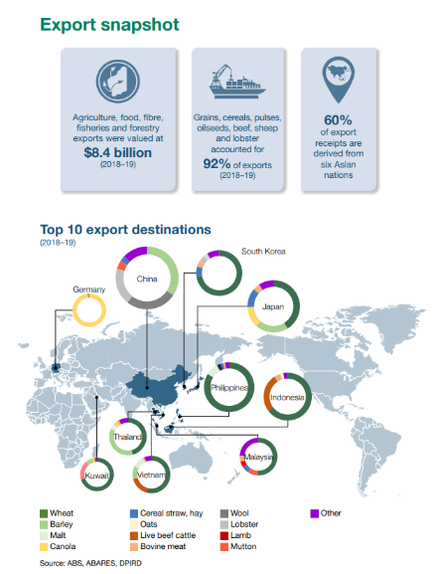  Image 1.1.2 |   Image 1.1.2

- Students create a one-minute pitch explaining why government should continue to support and invest in primary industries.
Examine the contribution/influence of the State Government on primary industry.
- Students suggest the ways in which the Federal and State governments influence/impact businesses involved in primary industry from ‘farm to fork’. For example, funding, research, regulations, trade and market access, promote economic growth, sustainable practices, international competitiveness, environmental issues, assistance during/after natural disasters or pandemics.
- Teacher to provide a brief background on how the WA Government supports primary industries and introduce the Primary Industries Plan. Primary Industries Plan 2020-2024
- Using a jigsaw instructional strategy, complete Student worksheet 3.1 - Strategic Initiatives.
- Create home groups - five students per group
- Number students 1, 2, 3, 4, 5 and hand out corresponding information sheet.
- Read and discuss requirements of the task.
- Move students into expert groups (same number) to complete the first the three tasks listed.
- Students return to home group and share their information.

Module 4: (1 – 3 lessons)
ENGAGE
EXPLORE
EXPLAIN
ELABORATE
EVALUATE

Learning intentions
Students will be able to:
- Investigate companies demonstrating improved productivity.

Background information
The following websites provide background information regarding productivity in Australia.
Home - Productivity Commission
PC Productivity Insights
Improving productivity and responding to economic conditions can occur in numerous ways. The case studies included provide examples of a new business, an established cooperative and a business that has diversified production.
If possible, use case studies from your local area.

Resources and equipment
Student resource
- Case Study - Eden Towers
- Case Study – Geraldton Fisherman’s Co-operative
- Case Study - Handasydes Strawberries
- Student worksheet 4.1 Business case study
- Student worksheet 4.2 Extent barometer

Instructions for suggested activities
- As a class, revise the definition of productivity and the ways in which a business can improve it. For example, technology, research and development, customer relationships, marketing strategies, management of resources, training and business planning.
- Organise students into groups of three and give each student a role. The roles are:
- The questioner
- The summariser
- The predictor.
- Distribute Student worksheet 4.1 Business case study and allocate one case study per group.
- Students to complete the worksheet – step 1 is an individual task and step 2 is a group task. Provide a time limit for each task based on your cohort.
- Reorganise students into different groups of three where each student can share their case study responses.
- Concluding activity suggestion: Students consider to what extent the case studies demonstrate commitment to the UN Sustainable Development Goals by completing Student worksheet 4.2 Extent barometer.
Step 1: for each goal, students gather evidence from the case studies
Step 2: decided on the extent barometer (0 – 100%) how high they would rate the commitment.
Step 3: provide an overall rating and provide justification in the general comments.
Extra activity:
Invite a guest speaker from your local area to discuss how they organise their business to improve productivity and respond to economic conditions.
Students/class to devise a series of questions to ask invited speaker to talk of their experiences.

Module 5: (2 – 3 lessons)
ENGAGE
EXPLORE
EXPLAIN
ELABORATE
EVALUATE

Learning intentions
Students will be able to:
- Understand the role of government, business and consumers in primary industry.

Background information
The Transform Peel project is a large scale, long-term project supported by all levels of government and private investment. It is an example of how stakeholders work together to provide increased productivity and contribute to the WA economy. It offers opportunities for businesses to be in proximity to research and development and training facilities.
Funding has been provided by the Federal and State Government. The project is targeting agri-food business including:
- Food manufacturers of all kinds
- Intensive food production, eg vertical farms, glasshouses
- Bio factories – businesses which produce food (and other products) from algae, enzymes, bacteria and fermentation
- Food researchers and institutions
- Food equipment manufacturers
- Start-ups that want to be a part of the ecosystem
The following websites provide detailed information regarding the project and demonstrate the links with the DPIRD research documents from Module 3.
Transform Peel
WA Food Innovation Precinct to drive growth in premium value-added foods
Peel Business Park

Resources and equipment
Teacher resource
- Peel Business Park
Other resources
- Student worksheet 5.1 mind map

Instructions for suggested activities
- Teacher to introduce the Peel Business Park project as an example of stakeholders working together to generate techniques to ensure future food security, generate jobs and income for the WA economy and develop relationships with emerging markets in the Middle East and Asian regions.
- Students complete Student worksheet 5.1 Mind map. The students will take notes regarding the project and then consider the Plus, Minus and Interesting aspects.
Schools outside of the metro/Peel area might like to consider the possibility/advantages of having a similar scheme available in their region. What type of businesses would benefit? Are transport links/facilities sufficient? Would research and development teams be willing to relocate?
- As a class, revise the information gathered from modules 1-5. That is, structure of a business system (inputs, processes, outputs); the types of careers and businesses involved in food and beverage production; government involvement in business development and examples of the ways in which businesses can increase productivity (technology, diversification or finding new markets).

- Students to respond to the initial question presented in Module 1:

‘How can governments, businesses and consumers interact to ensure a sustainable, efficient and cost-effective food production system?’

The responses could be:
  - written eg an essay; a report or infographic
  - individual oral presentations eg a speech, a podcast;
  - a class debate or panel discussion;
  - a design task eg creating an imaginary, innovative business that demonstrates key understandings.
For the written or oral presentations, the ‘audience’ could be the relevant Government Departments and/or current Ministers.
The following media statement outlines a plan for 20 high school students to form a ‘New WA Student Council’ to inform the Education Minister on school issues.
New student council to represent voices of young West Aussies

Acknowledgements

Images
Image 1.1.1 Western Australian Government (18 November 2020) ‘Primary Industries Plan 2020-2024’ available at: <https://www.wa.gov.au/government/publications/primary-industries-plan-2020-2024> accessed 13 August 2021
Image 1.1.2 Western Australian Government (18 November 2020) ‘Primary Industries Plan 2020-2024’ available at: <https://www.wa.gov.au/government/publications/primary-industries-plan-2020-2024> accessed 13 August 2021

References
Digital Learning Selector (n.d) ‘Hexagonal thinking’ New South Wales Government available at: <https://app.education.nsw.gov.au/digital-learning-selector/LearningActivity/Card/579> accessed 6 September 2021
Harte, Chris (12 September 2018) ‘A user’s guide to hexagonal thinking’ Unstuck learning design available at: <https://www.unstucklearning.design/post/2018/09/12/a-users-guide-to-hexagonal-thinking> accessed 6 September 2021
edX (29 March 2019) ‘Feeding a Hungry Planet: Agriculture, Nutrition and Sustainability I SDG Academy on edX’ ,YouTube, available at: <https://www.youtube.com/watch?app=desktop&v=k6-Riw0FUuU&feature=youtu.be> accessed 6 September 2021
OECD (8 April 2016) ‘The Future of Agriculture’ ,YouTube, available at: <https://www.youtube.com/watch?app=desktop&v=uAM4Si_WhDk&feature=youtu.be> accessed 6 September 2021
Department of Primary Industries (n.d) ‘Primary industry careers’ Department of Primary Industries available at: <https://www.dpi.nsw.gov.au/__data/assets/pdf_file/0005/735305/agriculture-careers-for-primary-school.pdf> [PDF 956 kB] accessed 6 September 2021
National Skills Commission (n.d) ‘Jobs by Industry’ Australian Government available at: <https://www.nationalskillscommission.gov.au/jobs-industry> accessed 6 September 2021
Buy West Eat Best (n.d) ‘Buy West Eat Best’ available at: <https://www.buywesteatbest.org.au/> accessed 6 September 2021
Agritourism WA (n.d) ‘Agritourism Western Australia’ available at: <https://www.agritourismwa.com.au/> accessed 6 September 2021
DevelopmentWA (n.d) ‘Peel Business Park’ Government of Western Australia available at: <https://developmentwa.com.au/projects/industrial-and-commercial/peel-business-park/overview> accessed 6 September 2021
Department of Primary Industries and Regional Development (18 August 2021) ‘Primary Industries Development Research Highlights 2021’ available at: <https://www.agric.wa.gov.au/primary-industries-development-research-highlights-2021> accessed 31 August 2021
Department of Primary Industries and Regional Development (n.d) ‘Target Market Opportunities: Detailed reports’ available at: <https://www.agric.wa.gov.au/form/target-market-opportunities-detailed-reports> accessed 31 August 2021
Department of Primary Industries and Regional Development (31 July 2018) ‘Pathway to Competitiveness Report’ available at: <https://www.agric.wa.gov.au/agricultural-exports/pathways-competitiveness-report> accessed 10 August 2021
Department of Primary Industries and Regional Development (26 July 2021) ‘Food Industry Innovation’ available at: <https://www.agric.wa.gov.au/r4r/food-industry-innovation> accessed 6 September 2021
Department of Primary Industries and Regional Development (18 August 2021) ‘Primary Industries Development Research Highlights 2021’ available at: <https://www.agric.wa.gov.au/primary-industries-development-research-highlights-2021> accessed 30 August 2021
Department of Primary Industries and Regional Development (24 September 2021) ‘Western Australian Agrifood Export eNews’ available at: <https://www.agric.wa.gov.au/export-services/western-australian-agrifood-export-enews> accessed 24 September 2021
Australian Government Business (n.d) ‘Support for businesses in Australia’ available at: <https://business.gov.au/> accessed 30 August 2021
Australian Government Business (10 September 2021) ‘Agriculture industry’ available at: <https://business.gov.au/planning/industry-information/agriculture-industry> accessed 30 August 2021
Australian Government Business (13 September 2021) ‘Fisheries industry’ available at: <https://business.gov.au/planning/industry-information/fisheries-industry> accessed 30 August 2021
Government of Western Australia Department of Treasury (August 2018) ‘Need for Government Intervention’: available at: <https://www.wa.gov.au/sites/default/files/2020-01/brp-fact-sheets-need-for-government-intervention.pdf> [PDF 196 kB] accessed 6 September 2021
Western Australian Government (18 November 2020) ‘Primary Industries Plan 2020-2024’ available at: <https://www.wa.gov.au/government/publications/primary-industries-plan-2020-2024> accessed 13 August 2021
Australian Government Productivity Commission (n.d) ‘Home - Productivity Commission’ available at: <https://www.pc.gov.au/> accessed 13 September 2021
Australian Government Productivity Commission (n.d) ‘PC Productivity Insights’ available at: <https://www.pc.gov.au/research/ongoing/productivity-insights> accessed 13 September 2021
Government of Western Australia (n.d) ‘Transform Peel’ available at: <https://www.peel.wa.gov.au/transformpeel/> accessed 13 September 2021
Future Food Systems (20 May 2021) ‘WA Food Innovation Precinct to drive growth in premium value-added foods’ available at: <https://www.futurefoodsystems.com.au/new-wa-food-innovation-precinct-to-help-produce-premium-value-added-food-products-in-australias-west/> accessed 14 September 2021
Government of Western Australia (20 September 2021) ‘New student council to represent voices of young West Aussies’ available at: <https://www.mediastatements.wa.gov.au/Pages/McGowan/2021/09/New-student-council-to-represent-voices-of-young-West-Aussies.aspx> accessed 21 September 2021

